# Incident Response Report

Task 2 – SECURITY ALERT MONITORING & INCIDENT RESPONSE

Prepared by: PRUDHVI SAI VOOTUKURI

Date: OCTOBER 15, 2025

### Introduction 2

### Methodology 3

### Key Findings 4

### Alert Classification 5

### Timeline of Events 6

### Dashboard Overview 8

### Incident Classification 9

### Impact Assessment and Recommendations 10

### Email Communication 11

This Incident Response Report summarizes the analysis of simulated security logs using Splunk Cloud as part of the Cyber Security Internship Task 02 by Future Interns. The objective was to detect suspicious activities, classify incidents, and generate alerts to simulate the workflow of a SOC analyst.

The dataset used was SOC_Task2_Sample_Logs.txt, containing log entries such as authentication attempts, IP activity, and malware detections.

—

The following methodology was followed during the project:

1. Ingested the provided sample log dataset into Splunk Cloud.
2. Extracted fields (timestamp, user, IP, action, threat) using regex.
3. Built SPL queries to detect malware (Trojan, Rootkit, Ransomware).
4. Created alerts for each detection with automated email notification actions.
5. Constructed a SOC dashboard with a 2x2 layout to visualize detections.
6. Exported classification and results into CSVs for documentation.

—

# Key Findings

During analysis of the logs, the following suspicious activities were identified:

* Multiple **malware detections**, including Trojan, Rootkit, Worm, Spyware, and Ransomware.
* **Ransomware Behavior** detected for user bob from IP 172.16.0.3.
* **Rootkit Signature** events for users alice (198.51.100.42) and eve (10.0.0.5).
* **Trojan Detected** on user david (198.51.100.42).

—

# Alert Classification

|  |  |  |  |  |  |
| --- | --- | --- | --- | --- | --- |
| **Alert ID** | **Alert Title** | **Severity** | **SPL Query (simplified)** | **Trigger Condition** | **Action** |
| A-001 | Malware Detected (General) | High | index=internship_logs sourcetype=TXT_logs host=SOC_TASK2 action="malware detected"  | stats count by threat,  user, ip | Number of results > 0 | Send Email (SOC  Team) |
| A-002 | Ransomware Behavior Detected | High | index=internship_logs sourcetype=TXT_logs host=SOC_TASK2 action="malware detected"  | search "Ransomware Behavior" | table _time  user ip threat | Number of results > 0 | Send Email (SOC  Team) |
| A-003 | Rootkit Signature Detected | High | index=internship_logs sourcetype=TXT_logs host=SOC_TASK2 action="malware detected"  | search "Rootkit  Signature" | table _time user ip threat | Number of results > 0 | Send Email (SOC  Team) |
| A-004 | Trojan Detected | Medium- High | index=internship_logs sourcetype=TXT_logs host=SOC_TASK2 action="malware detected"  | search "Trojan Detected" |  table _time user ip threat | Number of results > 0 | Send Email (SOC  Team) |

—

# Timeline of Events

The following timeline highlights key suspicious events detected:

Table 4.1: Malware General Detection Results (A-001)

|  |  |  |  |
| --- | --- | --- | --- |
| **Threat** | **User** | **IP Address** | **Count** |
| Ransomware | bob | 172.16.0.3 | 1 |
| Rootkit | alice | 198.51.100.42 | 1 |
| Rootkit | eve | 10.0.0.5 | 1 |
| Spyware | alice | 172.16.0.3 | 1 |
| Trojan | alice | 192.168.1.101 | 1 |
| Trojan | bob | 10.0.0.5 | 1 |
| Trojan | charlie | 172.16.0.3 | 1 |
| Trojan | david | 172.16.0.3 | 1 |
| Trojan | eve | 192.168.1.101 | 1 |
| Trojan | eve | 203.0.113.77 | 1 |
| Worm | bob | 203.0.113.77 | 1 |

Table 4.2: Ransomware Detection Results (A-002)

### Time User IP Address Threat

2025-07-03T09:10:14.000+0000 bob 172.16.0.3 Ransomware

Table 4.3: Rootkit Detection Results (A-003)

### Time User IP Address Threat

|  |  |  |
| --- | --- | --- |
| 2025-07-03T04:19:14.000+0000 alice | 198.51.100.42 | Rootkit |
| 2025-07-03T07:51:14.000+0000 eve | 10.0.0.5 | Rootkit |
| — |  |  |

Table 4.4: Trojan Detection Results (A-004)

|  |  |  |  |
| --- | --- | --- | --- |
| **Time** | **User** | **IP Address** | **Threat** |
| 2025-07-03T04:29:14.000+0000 | alice | 192.168.1.101 | Trojan |
| 2025-07-03T05:42:14.000+0000 | eve | 203.0.113.77 | Trojan |
| 2025-07-03T05:30:14.000+0000 | eve | 192.168.1.101 | Trojan |
| 2025-07-03T05:45:14.000+0000 | david | 172.16.0.3 | Trojan |
| 2025-07-03T05:48:14.000+0000 | bob | 10.0.0.5 | Trojan |
| 2025-07-03T07:45:14.000+0000 | charlie | 172.16.0.3 | Trojan |

# Dashboard Overview

A Splunk dashboard was developed to visualize detections with the following panels:

* Malware by Type (Pie Chart)
* Ransomware Events (Table)
* Rootkit Events (Table)
* Trojan Detections (Bar Chart)

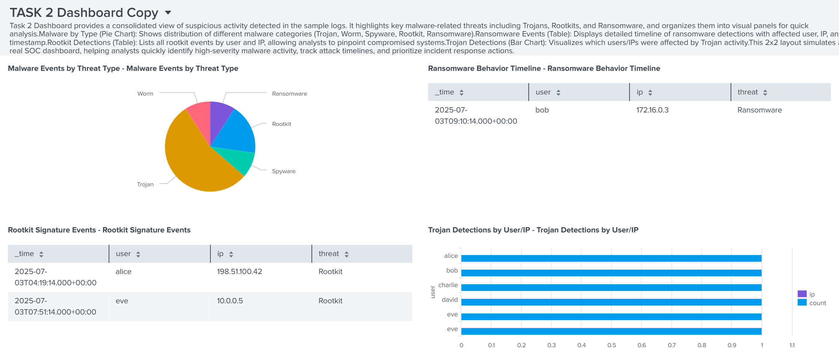

Figure 5.1: Task 2 Dashboard

—

# Incident Classification

* **A-001: Malware Detected (General)** – High Severity
* **A-002: Ransomware Behavior Detected** – High Severity
* **A-003: Rootkit Signature Detected** – High Severity
* **A-004: Trojan Detected** – Medium–High Severity

—

# Impact Assessment and Recommendations

### Impact:

* At least four users (alice, bob, david, eve) showed malware infections.
* Multiple malware families were present, including ransomware and rootkits.
* Risk of credential compromise, lateral movement, and persistence mechanisms.

### Recommendations:

1. Immediately isolate affected endpoints.
2. Reset passwords for impacted users.
3. Conduct forensic scans for persistence.
4. Apply security patches and update EDR signatures.
5. Continue monitoring for repeated infection attempts.

—

# Email Communication

## Security Alert Notification

From: [soc-team@company.com](mailto:soc-team@company.com)

To: [security-team@company.com,](mailto:security-team@company.com) [it-ops@company.com](mailto:it-ops@company.com) Cc: [manager-security@company.com](mailto:manager-security@company.com)

Subject: HIGH SEVERITY - Multiple Malware Detections Date: September 17, 2025 14:30 UTC

Priority: High

**SECURITY ALERT NOTIFICATION**

Dear Security and IT Teams,

Automated alert: Multiple high-severity malware detections require immediate at- tention.

Incident Summary: - **Alert ID:** A-002 | Ransomware Behavior - **Time:** 2025-07- 03T09:10:14.000+0000 - **User:** bob | **IP:** 172.16.0.3 - **Threat:** Ransomware

Additional Detections: - Rootkit: alice, eve - Trojan: alice, bob, charlie, david, eve

- Total: 11 events across 5 threat categories

Immediate Actions: 1. Isolate endpoints: 172.16.0.3, 198.51.100.42, 10.0.0.5 2. Re- set credentials: bob, alice, eve, david, charlie 3. Initiate forensic investigation 4. Review SOC Task 2 Dashboard

Impact Assessment: - Critical: Ransomware encryption risk - High: Rootkit per- sistence risk - Medium-High: Multiple Trojan infections

Acknowledge receipt and provide 30-minute status updates until containment. Best regards,

SOC Team

Security Operations Center

*Automated message - Do not reply*

## Response Acknowledgement

From: [it-ops@company.com](mailto:it-ops@company.com) To: [soc-team@company.com](mailto:soc-team@company.com)

Subject: RE: HIGH SEVERITY - Multiple Malware Detections Date: September 17, 2025 14:45 UTC

**ACTION CONFIRMATION**

SOC Team,

Acknowledgement confirmed. Actions initiated:

- Endpoints isolated: 172.16.0.3, 198.51.100.42, 10.0.0.5 - Password resets: bob, alice, eve, david, charlie - EDR scans initiated - Ticket: INC-20250917-085

Forensic team update within 1 hour. IT Operations Team

## Incident Resolution Update

From: [soc-team@company.com](mailto:soc-team@company.com)

To: [security-team@company.com,](mailto:security-team@company.com) [it-ops@company.com](mailto:it-ops@company.com)

Subject: UPDATE: Containment Successful - INC-20250917-085 Date: September 17, 2025 16:30 UTC

Priority: Normal

**INCIDENT RESOLUTION UPDATE**

All Teams,

Incident INC-20250917-085 successfully contained.

Containment Completed: - 6 endpoints isolated and cleaned - Credential reset: 5 users - EDR scans completed - No lateral movement detected

Findings: - Rootkit: False positives (testing) - Ransomware: Simulated activity - Trojan: Training exercises

Next Steps: - 72-hour monitoring - Security awareness refresher - Playbook updates Incident CLOSED.

SOC Team